ARCHER Technical Assessment Form: Grant, RAP, Leadership Applications
Note: this form is for grant applications (e.g. RCUK, ERC, Wellcome Trust, Royal Society), RAP,and Leadership Applications. Technical Assessment forms for other access routes can be found on the ARCHER website at http://www.archer.ac.uk/access

Instructions:
- Complete Section 1 below as fully as possible. If you have any questions or require clarification, please contact the ARCHER helpdesk (support@archer.ac.uk).
- Return the completed form (as a Word document) to the ARCHER helpdesk (support@archer.ac.uk) along with a draft of your Case for Support.
- The ARCHER CSE team will complete Section 2 and will contact you directly for more information if it is required. This may take up to 10 days from receipt of the completed form.
- The CSE team will return the fully completed form to you so you can include it in your grant/RAP application.

Notes for EPSRC Grant Applications:
- You can apply for ARCHER resources for a maximum of 3 years. Further resource beyond this date should be applied for via the RAP Top Up process.
- You must supply quantitative evidence that the codes to be used scale to the core counts requested. More details on the evidence required can be found in Section 1, Part 6.

Notes for non-RCUK Grant Applications:
- If eligible, access costs for ARCHER should be included in the grant application on basis of the rate for non-partner organisations.
- You must supply quantitative evidence that the codes to be used scale to the core counts requested. Details on the evidence required can be found in Section 1, Part 6.
- You should indicate in section 1.2 whether the research remit is EPSRC or NERC.

Notes for RAP Applications:
- You can apply for ARCHER resources for a maximum of 1 year for RAP.
- You must request at least 1000 kAU.
- You must supply quantitative evidence that the codes to be used scale to the node counts requested. Details on the evidence required can be found in Section 1, Part 6.
- Further notes can be found at: http://archer.ac.uk/access/rap/.

Notes for Leadership Applications:
- You can apply for ARCHER resources for a maximum of 2 years for Leadership Projects.
- You must supply quantitative evidence that the codes to be used scale to the core counts requested. Details on the evidence required can be found in Section 1, Part 6.
- Further notes can be found at: http://archer.ac.uk/access/leadership/.

Completion of this form implies permission for user details to be stored in the Service Partners’ and Research Councils’ databases and to be used for mailing, accounting, reporting and other administrative purposes.

Section 1: HPC Resources and Case for Support (To be completed by the applicant).

- Project Information.

  - Project Title: [Enter project title]
  - Application Type: [Grant]/[RAP]/[Leadership]/[non RCUK Funding Body and NERC/EPSRC remit]

  - PI Name and Contact Details.

Name: | [Please Complete Table]
Department:
Institution:
Position Held:
Address:
Postcode:
e-Mail:
Telephone:
Nationality:

  - Contact details for application (if different from PI above)

Name: | [Please Complete Table]
Department:
Institution:
Position Held:
Address:
Postcode:
e-Mail:
Telephone:
Nationality:

  - Proposed start date of ARCHER use: [Enter start date]

  - Project length (months) of ARCHER use: [Enter project length, max. 1 year for RAP, max. 2 years for Leadership, max. 3 years for EPSRC grants, no limit for non-RCUK grants]

- Previous Use of HPC Resources.

  - Are you an existing ARCHER user? [Yes/No]

  - Which other HPC services have you used?

[Enter list of other HPC services]

  - If you have used other HPC services please provide a brief summary of the number of core hours used and the types of jobs run (codes, core counts, typical job lengths):

[Enter summary of previous service usage]

- ARCHER Software and Support Requirements.

Summary of software requirements.

What are the main codes you will be using? A description of available software on ARCHER is given here http://www.archer.ac.uk/documentation/software/. Please provide links to codes/software not presently available on ARCHER.

[Enter list of codes with links to descriptions if possible]

Software requirements (e.g. compilers, libraries, tools):

[Enter list of software requirements to support your use of ARCHER]

Support Requirements
How do you plan to port and optimize your code on ARCHER (delete as appropriate)?

Expertise in your group | Yes/No/NA
ARCHER CSE Support | Yes/No/NA
Other (please specify)

Please summarise any other support requirements for this project:

[Enter any other support requirements]
- Proposed Use of ARCHER Resources.

  - Job size mix for the project
The online kAU calculator (http://www.archer.ac.uk/access/au-calculator/) can be used to help complete this table and contains a list of kAU rates.
There are 24 cores per node on ARCHER. Generally we would expect users to use all cores on a node. If you cannot use all cores on a node please ensure you have stated why in Section 6 below.
Please see notes at beginning of this document regarding the maximum amounts of time that can be applied for and consult any call guidelines.

 | Largest Job | Typical Job | Smallest Job
Number of nodes | [Please Complete Table]
Number of cores used per node (usually 24)
Wallclock time for each job (Max. 48h)
Number of jobs of this type
Total memory required.

Total kAU: [Enter total kAU from kAU calculator]
Notional Cost: [Enter total notional cost from kAU calculator]

  - Disk space requirements.
You may find it easier to complete this section after completing Section 7 (Data Management and Transfer) below.
/home: Small, backed-up. For project critical files (e.g. source code).
/work: Large, high-performance, not backed-up. For input and output from calculations.
RDF: Large, backed-up, long-term. Data analysis and long term data storage.

 | Storage
/home (required) | [e.g. 10 GB]
/work (required) | [e.g. 1 TB]
RDF (optional)
- Usage Breakdown by 6-month Periods

*This Section does NOT need to be filled in by applicants to the RAP, but is compulsory for all other applicants including top-up applications through the RAP.

The total number of kAU requested above must be broken down into 6-month periods that span the length of access to ARCHER that has been requested (e.g. if you have requested 1 year of access in total then the kAUs must be split into two 6 month periods). Please add the correct number of rows to the table below for the total length of your project (e.g. for a 36 month project you would need 6 rows).
If your application is successful then these period allocations will be enforced on ARCHER in the following way:
- Any unused allocation at the end of a period is lost
- You cannot move kAU between different allocation periods

Period 1 (months 0-6) | [e.g 1000 kAU]
Period 2 (months 7-12)
Period 3 (months 13-18)
Period 4 (months 19-24)
Period 5 (months 25-30)
Period 6 (months 31-36)

- Scaling Evidence to Support Proposed Use of ARCHER
The number of kAUs requested and the job sizes specified in 4.1 above must be backed up by quantitative evidence that the code scales efficiently to the job sizes requested. The evidence must include:
- A graph or table of the speedup for a similar problem using the code on ARCHER or another HPC system. The speedup should be provided relative to the smallest number of cores that can be used feasibly (see examples below).
If the application is developing new algorithms for which scaling data is not yet available then the proposed scaling should be justified with appropriate references and descriptions.
If you require help in evaluating the speedup of a code on a particular problem then please contact the ARCHER Helpdesk (support@archer.ac.uk)
[Enter Resource Justification]
Example speedup table:
 | Runtime / s
Cores | Run 1 | Run 2 | Run 3 | Mean | Speedup
96 | 625.7 | 613.4 | 634.6 | 624.6 | 1.00
192 | 318.5 | 312.5 | 323.1 | 318.0 | 1.96
384 | 159.7 | 161.2 | 157.4 | 159.4 | 3.92
768 | 81.2 | 81.4 | 81.1 | 81.2 | 7.69
1536 | 45.4 | 45.0 | 46.1 | 45.5 | 13.73
Example speedup graph:
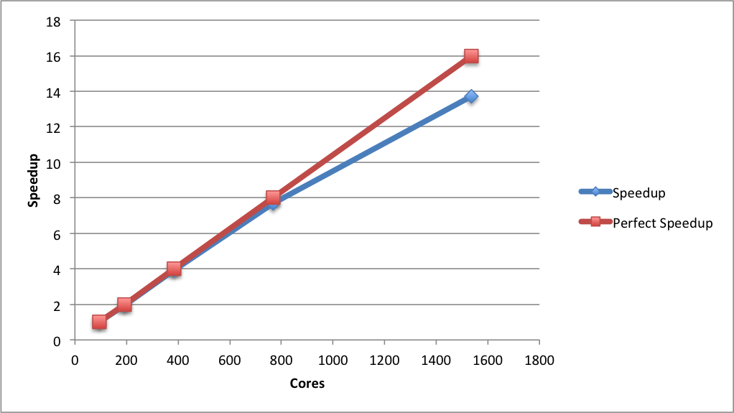
- Data Management and Transfer
This section asks some basic questions about the data generated on ARCHER by the proposed calculations. You may find the advice in the ARCHER Data Management Guide useful in answering these questions, see:
http://www.archer.ac.uk/documentation/data-management/
Projects on ARCHER can also request space on the RDF and gain access to the RDF Data Transfer Nodes and Data Analytic Cluster. For more information on the RDF, see:
http://www.archer.ac.uk/documentation/rdf-guide/

7.1 How many files are typically produced by each job?
[Enter the estimated number of files. This does not need to be exact, order of magnitude is sufficient here. For example, 1000 files per job. You should also state how these files are organised; for example, are they all stored in one directory or is there a hierarchy of directories?]
7.2 How much data is read in by each job?
[Enter estimated total size in kB/GB/TB]
7.3 How much data is produced by each job?
[Enter estimated total size in GB/TB/PB]
7.4 What percentage of the produced data do you expect to transfer?
- To the RDF? [Enter estimated percentage]
- Off ARCHER/RDF? [Enter estimated percentage]
7.5 How do you plan to transfer data from ARCHER to the RDF?
[If you plan to use the RDF to store, transfer and/or analyse data please describe the mechanism by which you will move data from ARCHER to the RDF. Will these transfers be manual or automated? You should also state roughly the amount of data that will be transferred in each transfer instance (i.e. how will the transfers be batched up).]
7.6 How do you plan to transfer data off ARCHER/RDF?
[Please describe the mechanism you will use to transfer data from ARCHER/RDF to external sites for further analysis or archive. Please also state the sites that you will be transferring data to. You should also state roughly the amount of data that will be transferred in each transfer instance (i.e. how will the transfers be batched up).]

Section 2: Technical Assessment (To be completed by CSE team).

Date Received by CSE: [Enter received date]

Do the applicants have the technical expertise required for the proposed work? | Yes/No

Is the software specified technically suitable for ARCHER? | Yes/No

Is the compute time requested reasonable and has the job breakdown been technically justified? Are the storage requests reasonable? | Yes/No

Has scaling evidence been provide that shows speedup to required job size for the software specified? | Yes/No

Is the data management and transfer plan reasonable and technically sound? | Yes/No

Is the application, as outlined above, suitable for access to the ARCHER service? Yes / No

Does the project require the technical capabilities of ARCHER?
Would a different computing resource be more appropriate?

Name: [Enter name]
Position: [Enter job title]
Date: [Enter date completed]

